Homework #9
(Module 9: Automated Switching and Reconfiguration)

Question 1: What is the major difference between a switch and a circuit breaker?
- A switch can be reset from a remote location.
- A switch automatically disconnects a feeder from a faulted section.
- A circuit breaker can break fault current.
- A circuit breaker can reconfigure a feeder.
Question 2: What is a benefit of using a circuit breaker over a fuse?
- A crew does not have to be dispatched to reset a circuit breaker.
- A circuit breaker can break fault current.
- A circuit breaker can automatically reconnect a segment back to the main feeder.
- All of the above.
Question 3: Which is not a protection device?
- Fuse
- Circuit breaker
- Switch
- Sectionalizer
Question 4: Which is not used to take equipment out of service and/or reconfigure a feeder?
- Switch
- Circuit breaker
- Recloser
- Fuse
Question 5: What other piece of equipment is used in conjunction with a sectionalizer?
- Circuit breaker
- Recloser
- Switch
- None
Question 6: Given a fault on line 708-732 on the feeder shown below, what protection device takes action?
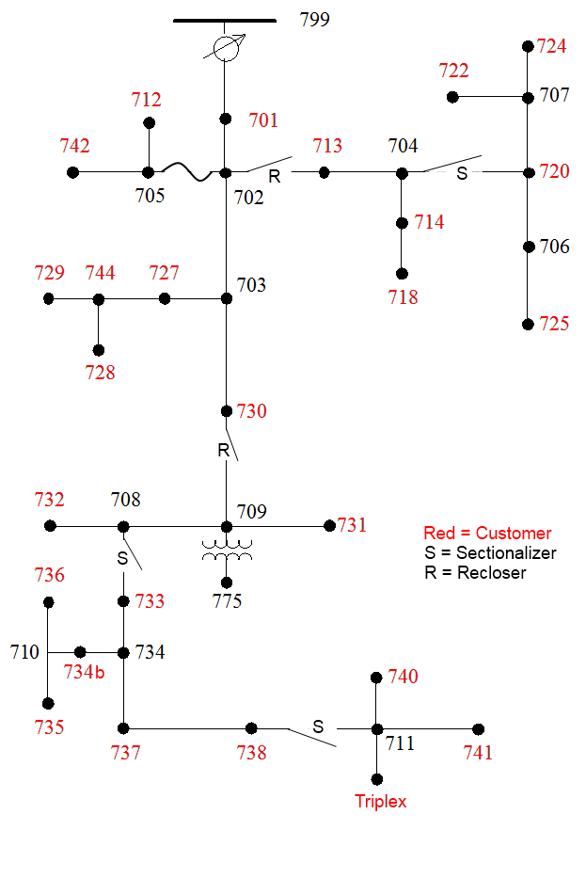
- Sectionalizer 708-733 and recloser 730-709
- Recloser 730-709
- Sectionalizer 738-711 and recloser 730-709
- Recloser 702-713
Question 7: Given a fault on line 734-737 from the feeder shown in Question 8, what protection device takes action?
- Sectionalizer 708-733 and recloser 730-709
- Recloser 730-709
- Sectionalizer 738-711 and recloser 730-709
- Recloser 702-713
Question 8: Given a fault on line 714-718 from the feeder shown in Question 8, what protection device takes action?
- Sectionalizer 708-733 and recloser 730-709
- Recloser 730-709
- Sectionalizer 738-711 and recloser 730-709
- Recloser 702-713
Question 9: From the feeder shown in Question 8, what would happen if there were a fault on line 703-730?
- Recloser 730-709 would trip.
- Nothing
- Fuse 702-705 would blow.
- A complete blackout on the feeder.
Question 10: What is the benefit of using automated (smart) switchgear on a feeder?
- Quicker response reacting to and disconnecting a fault from a feeder.
- Being able to reset the switchgear from the control room instead of dispatching a crew.
- Being able to more quickly identify a fault location.
- Both (2) and (3).

